**ASSIGNMENT-4**

|  |  |
| --- | --- |
| Assignment Date | 28 October 2022 |
| Student Name | Ms. Dhivya V |
| Student Roll Number | 820419104019 |
| Maximum Marks | 2 Marks |

1. **Pull an Image from docker hub and run it in docker playground.**

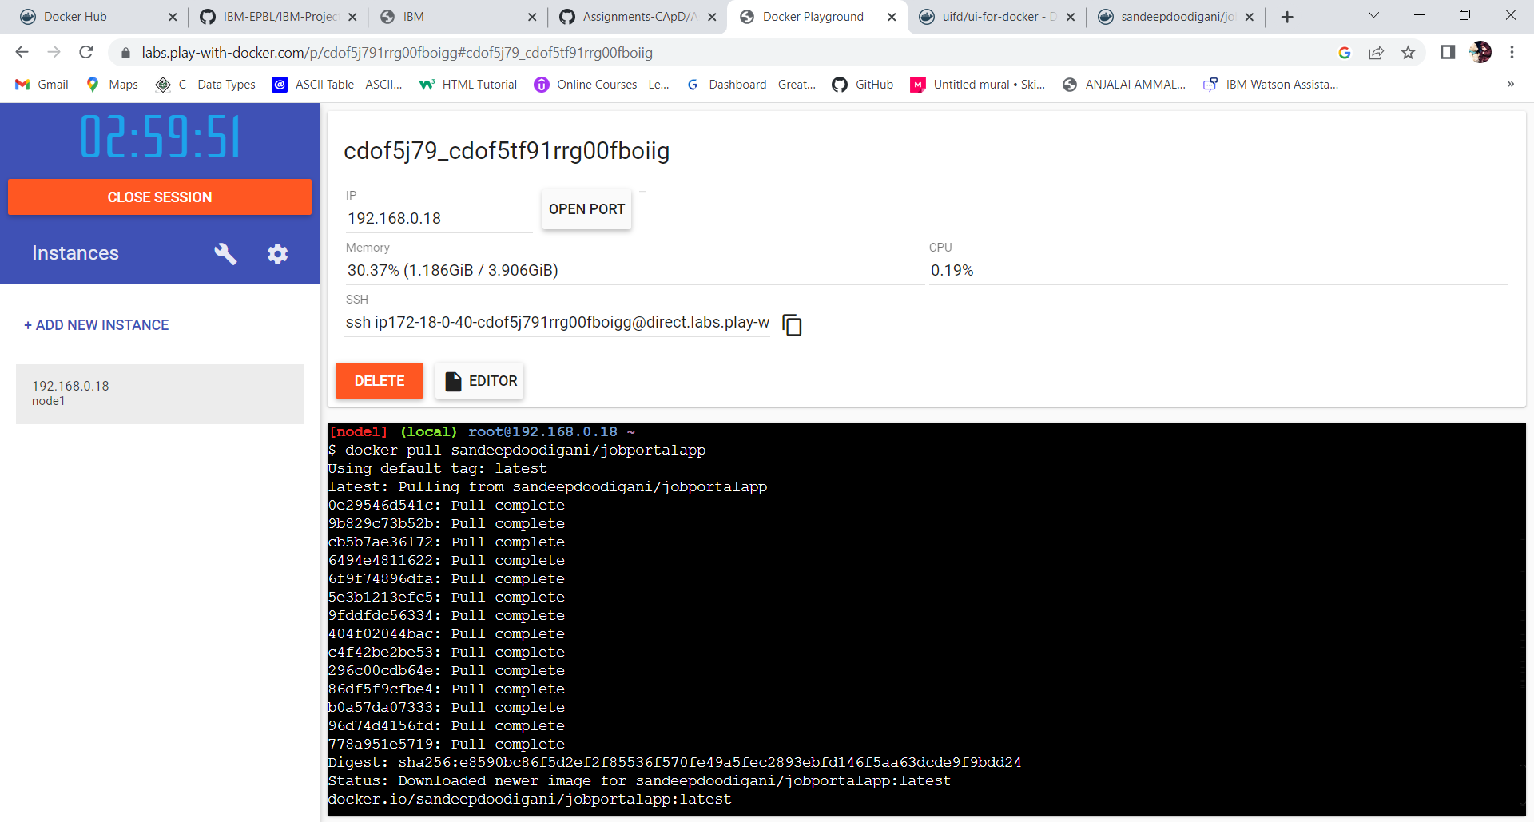

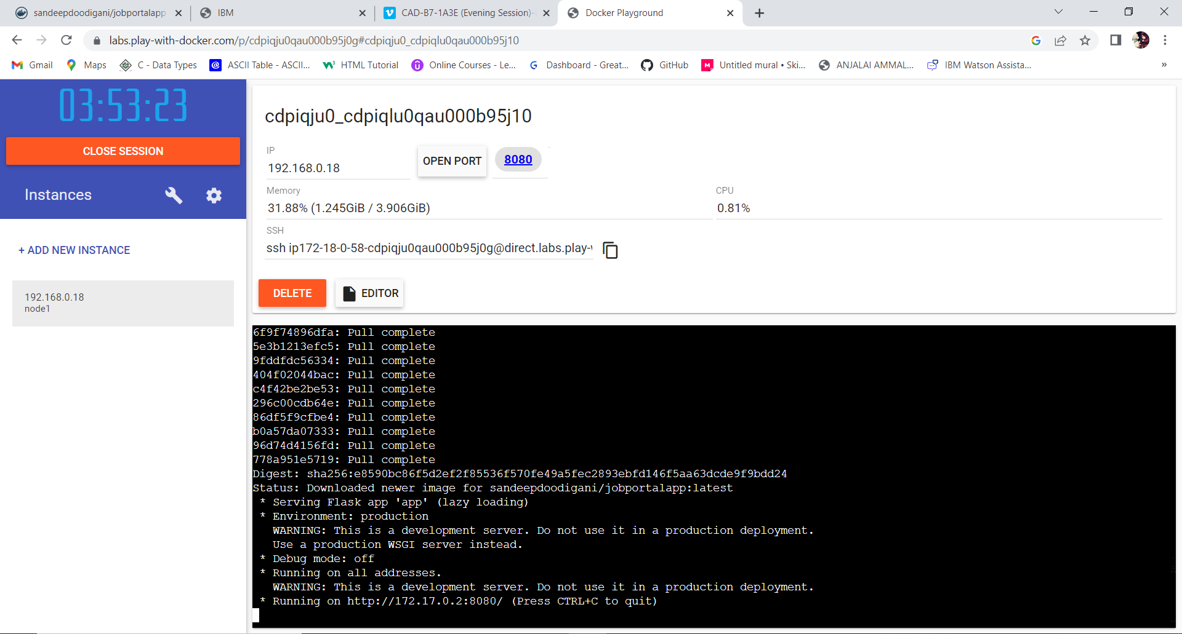

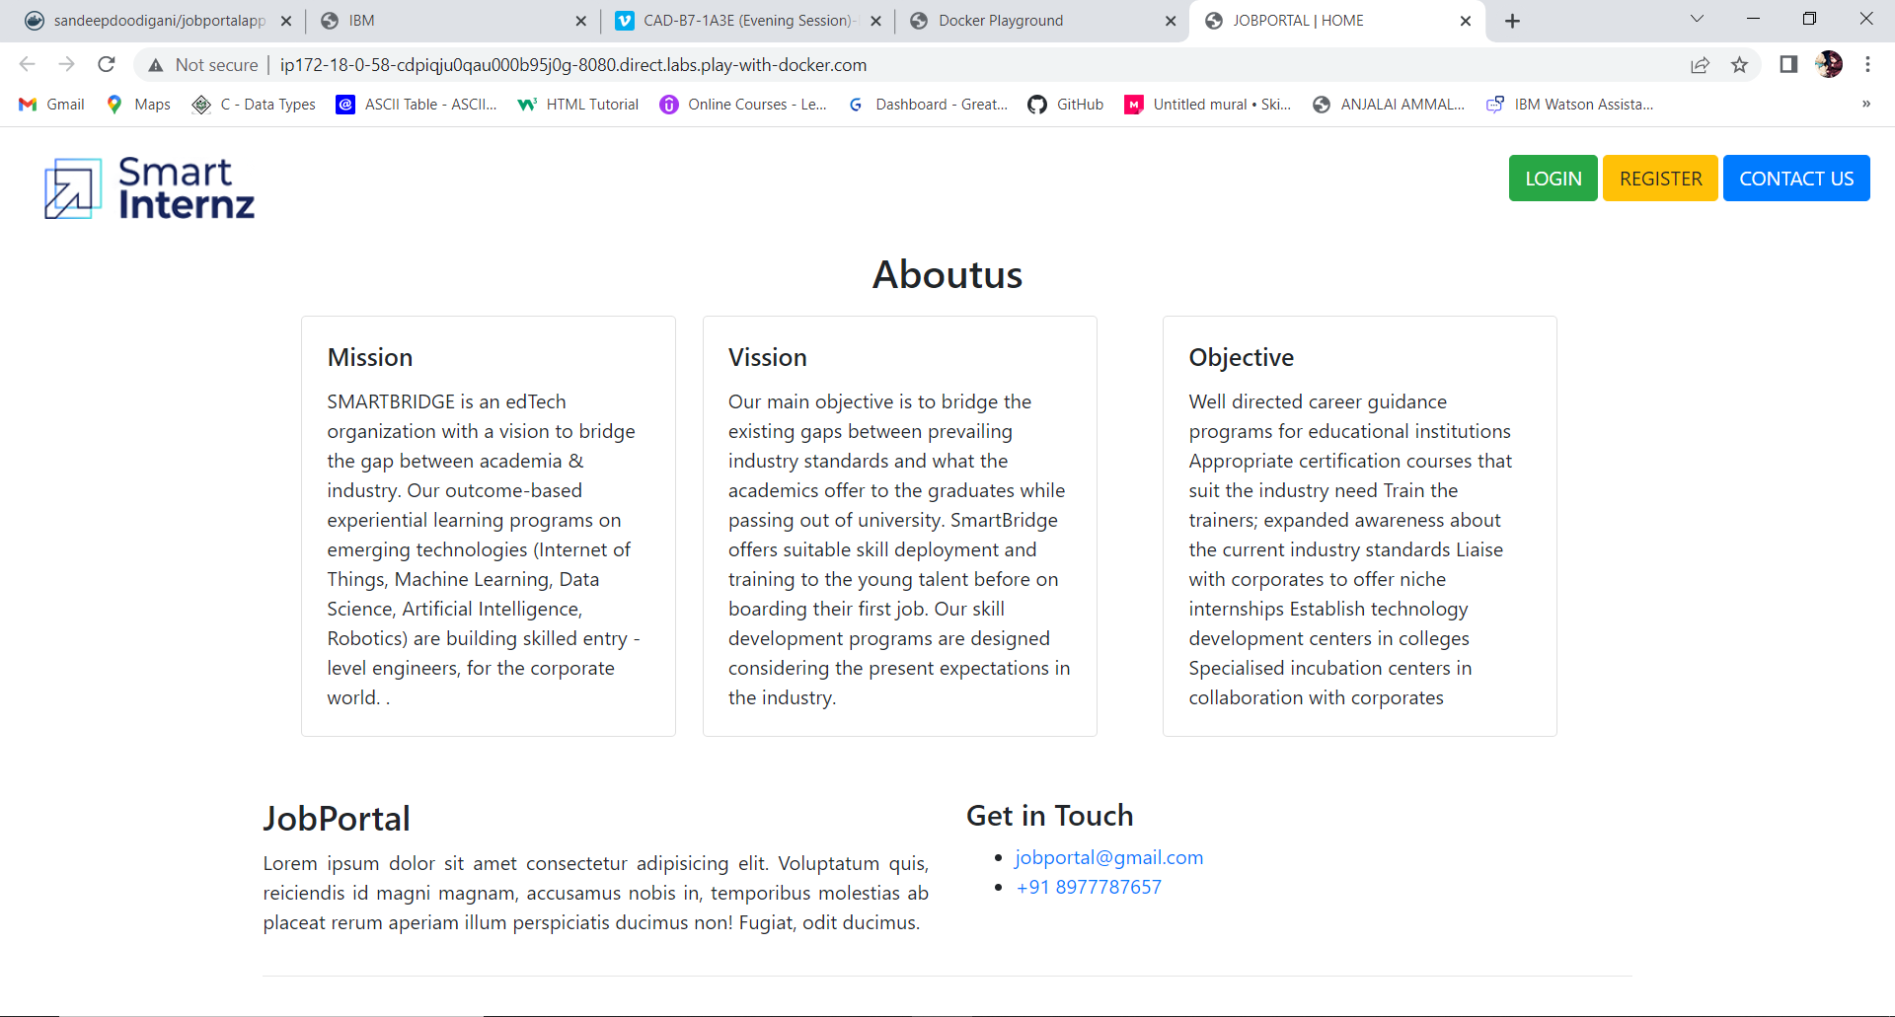

**2.Create a docker file for the jobportal application and deploy it in Docker desktop application.**

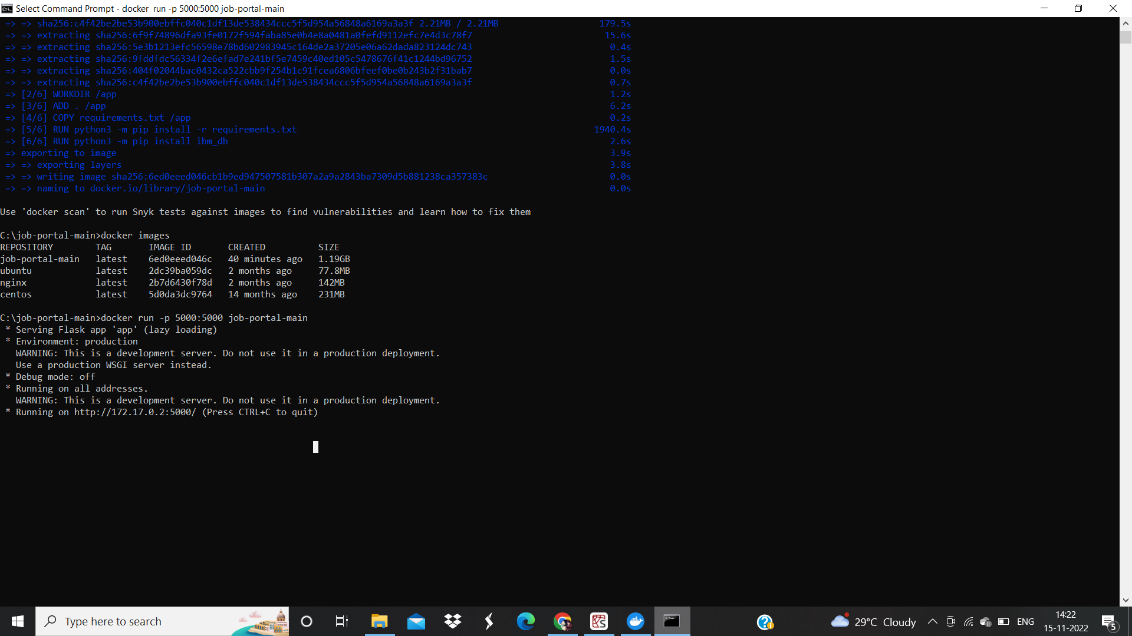

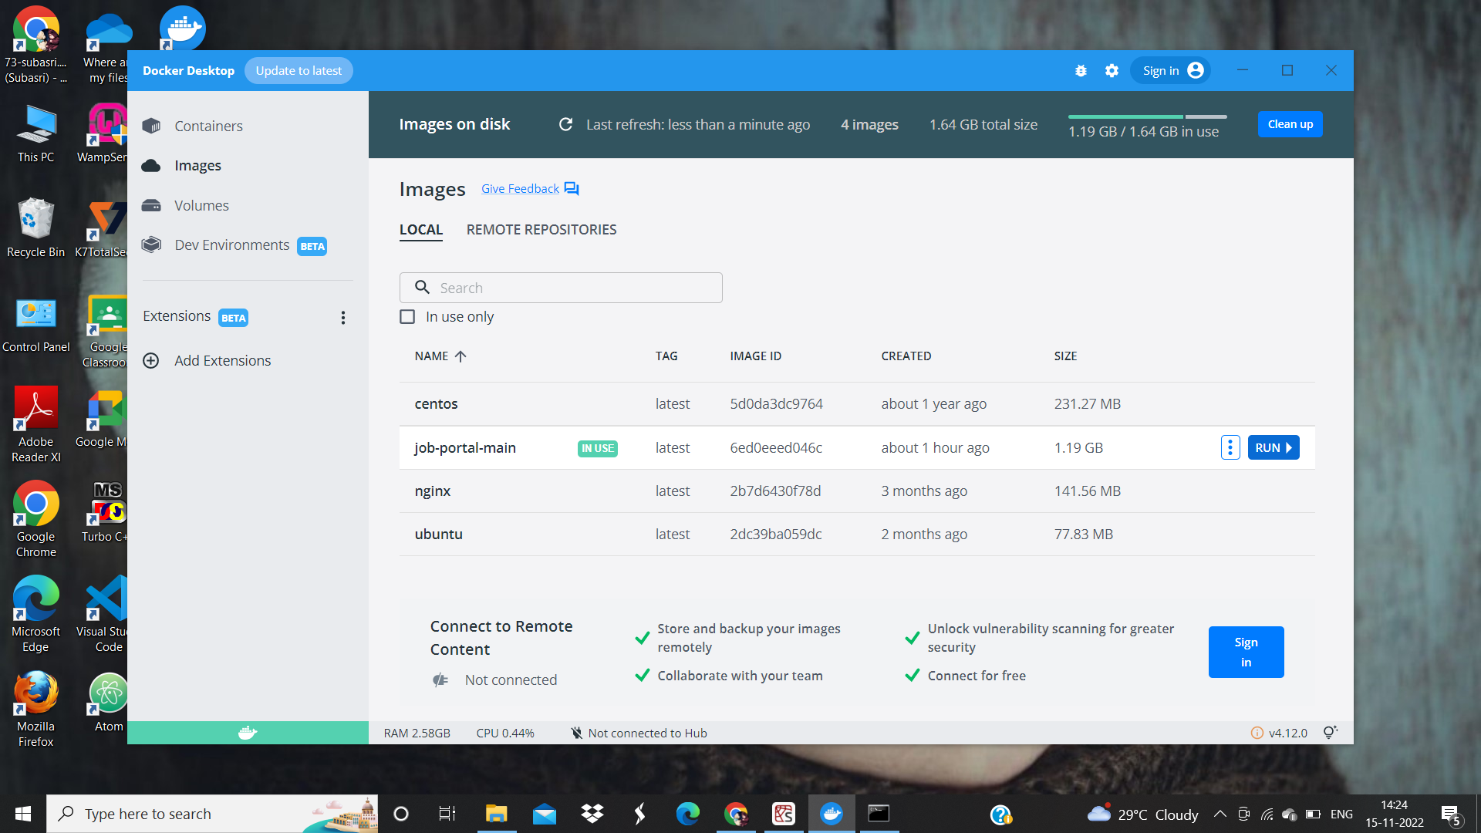

**3.Create a IBM container registry and deploy helloworld app or jobportalapp.**

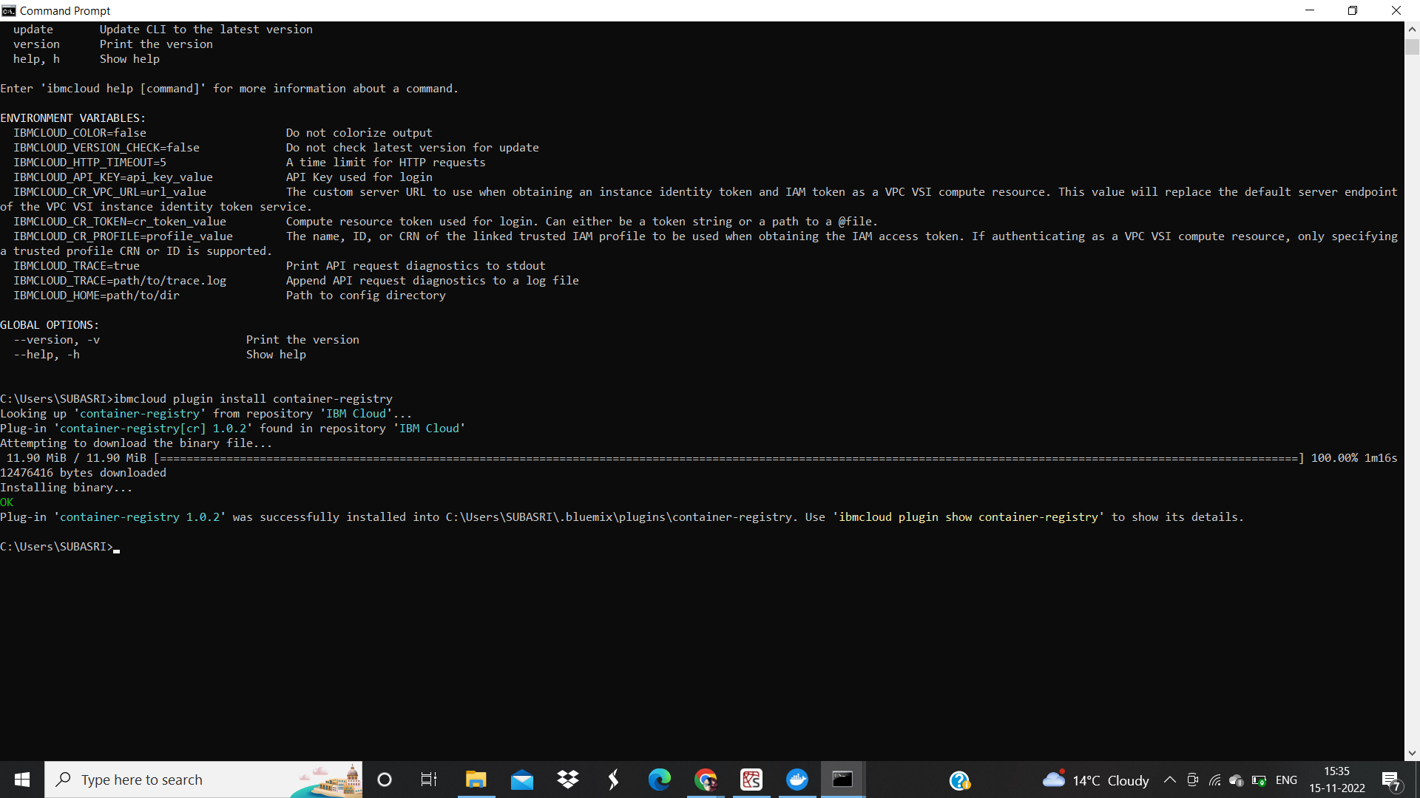

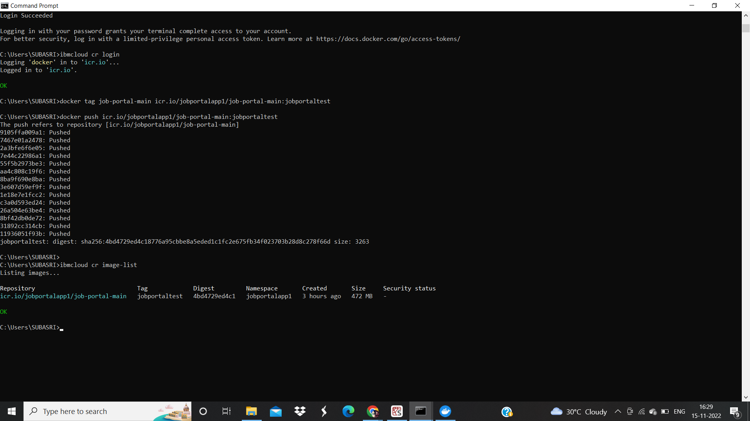

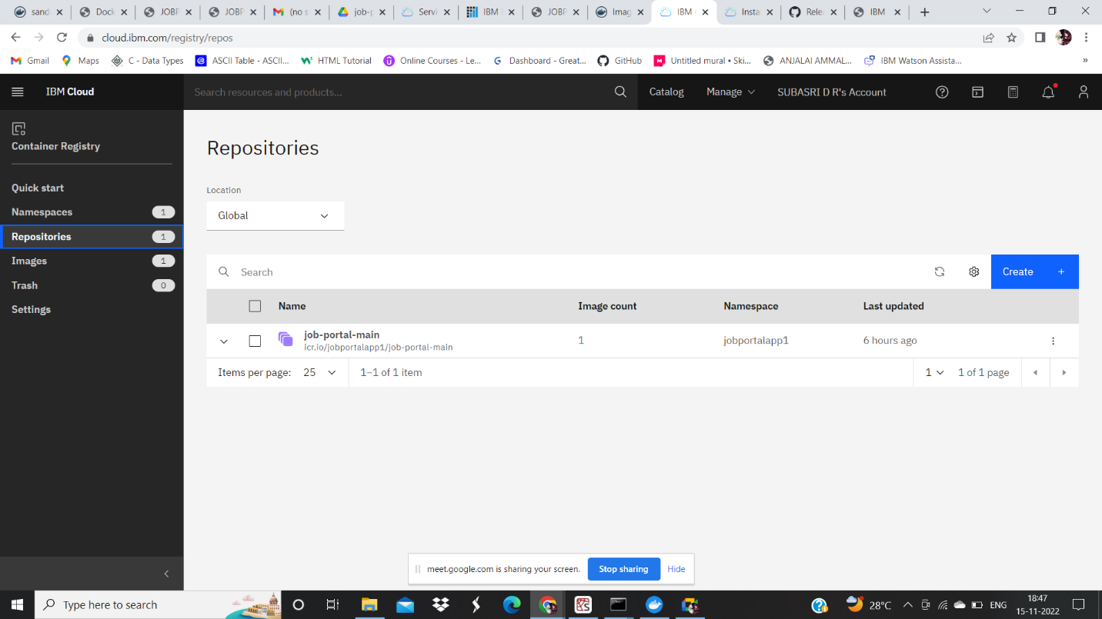

**4.Create a Kubernetes cluster in IBM cloud and deploy helloworld image or jobportal image and also expose the same app to run in nodeport.**

